PROTECT Release Notes
October 2026

Revised PROTECT Login Appearance
Over the next week, PROTECT system users will start to see a change to the appearance of their login screen on both the PROTECT PROD and TRAINING environments. This is part of the impact from NIH’s centralization of IT resources.
How the login process works will not change. How it appears on screen will just be slightly different: The NIH User buttons and Non-NIH User buttons will simply no longer be stacked one on top of the other, vertically. They will now be side-by-side, horizontally. (see screenshot below)
Questions? Contact Sue Tindall directly for support | suetindall@nih.gov or via Teams.
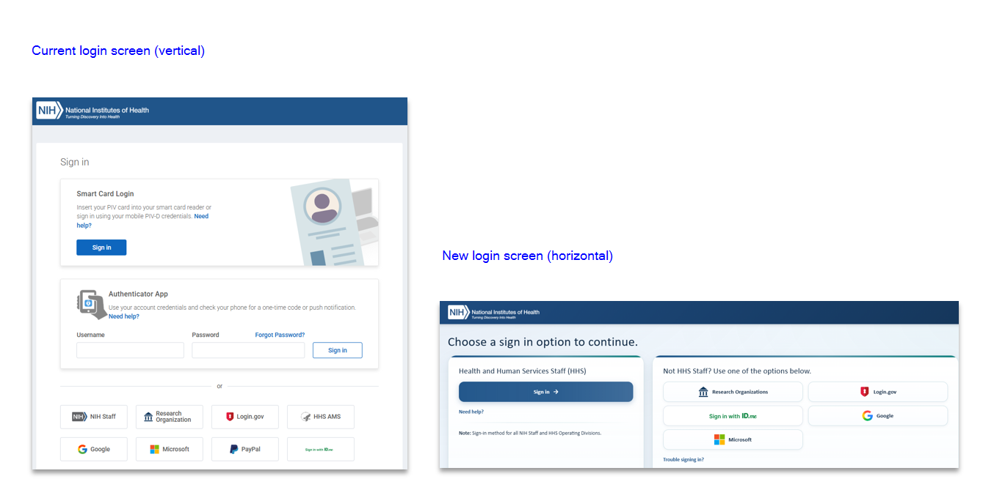

New IRB workspace fields
Five new data fields will now appear on the IRB submission workspaces:
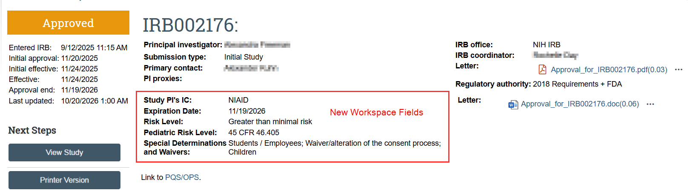
Below is a summary of each field, where the data originate from, and what they mean for the submission:
- Study PI’s IC
This field is the Study PI’s IC, NOT the IC for the study itself if that differs. It comes from their NED profile.
  - For a new study, this will show the IC of the person selected as PI on the IRB submission form, page 1.
  - If a PI change is later requested on a subsequent MOD, it will show the new PI’s IC. Once the MOD is IRB approved, the newly-added PI’s IC will copy over to the IR workspace as well so they are up-to-date and congruent.
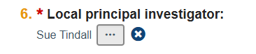

- Expiration Date | Risk Level | Pediatric Risk Level
These fields come from the IRB when they record their IRB review outcome, after a Committee or Designated Review.
  - New Studies: For a newly submitted study, these values will be blank until the IRB review occurs and their outcome is recorded by IRB Staff.
  - Follow-On Submissions: If a subsequent follow-on-submission is later submitted, these values will reflect that of the approved parent study – unless/until they get revised based on the IRB review outcome. Once the Follow-On-Submission moves to Approved, these values will copy over to the IR workspace as well so they are up-to-date and congruent.
  - Site/Site Mods: For Site/Site Mod workspaces, these values always reflect that of the parent study.
  - External Studies/Study Updates: For External studies, these values are what is entered when IRB staff Records/Edits the SIRB Decision.

- Special Determinations and Waivers
This field comes from the IRB when the IRB staff Submits their Pre-Review of the study.
  - New Studies: For a newly submitted study, these values will be blank until the IRB staff submits their Pre-Review of the study.
  - Follow-On Submissions: If a subsequent follow-on-submission is later submitted, these values will reflect that of the approved parent study – unless/until they get revised based on the IRB Pre-Review. Once the Follow-On-Submission moves to Approved, these values will copy over to the IR workspace as well so they are up-to-date and congruent.
  - Site/Site Mods: For Site/Site Mod workspaces, these values always reflect that of the parent study’s Special Determinations and Waivers.
  - External Studies/Study Updates: For External studies, these values are what is entered when IRB staff Records/Edits the SIRB Decision.

Change 3 - Revised Multisite table
Added new Questions to IRB Submission Form P1 Q8. These appear on the site table drill-down view:
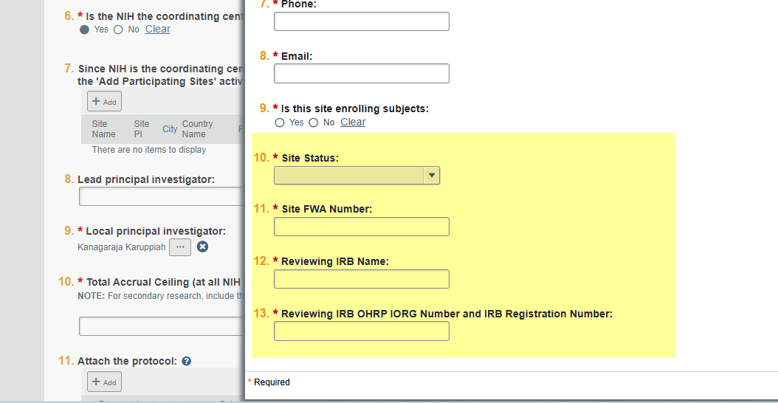
Columns were also added on the table to display the answers to these new Qs:
Previous table:
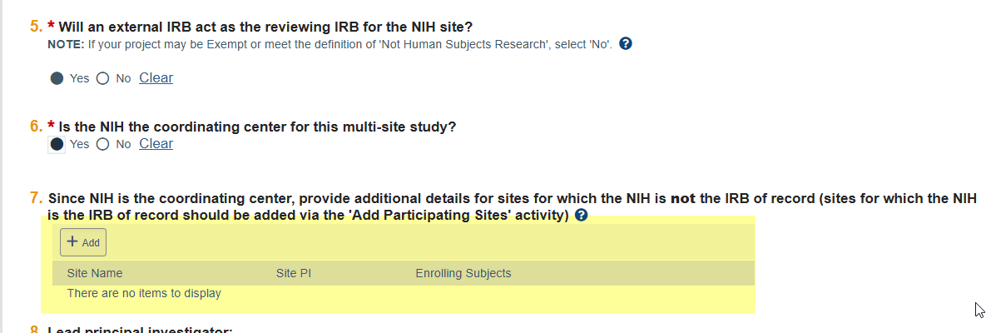
Revised table:
The question containing this revised table will now be a required question, indicated by a red asterisk *.
NOTE: New Qs will have blank values on existing submissions. This means that study teams must now complete these Qs when they submit new studies, mods, or submit responses on studies where this Q is displayed (where NIH is the coordinating center = YES), and the new Qs are blank: 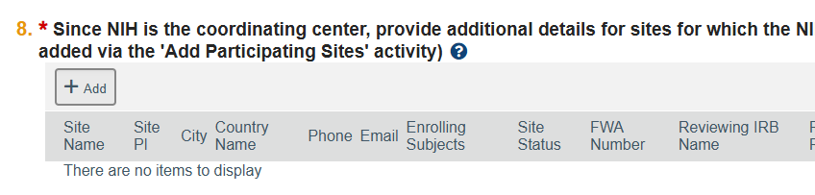
Validation message will look like this:
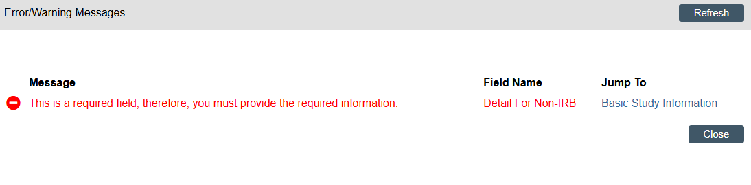
Added new help text on the following question, page 1 of the IRB submission form:
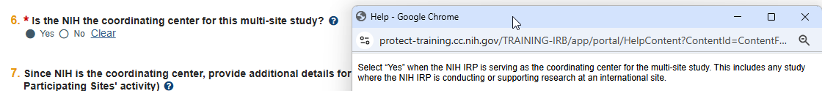
Revised the help text on the following question, page 1 of the IRB submission form:
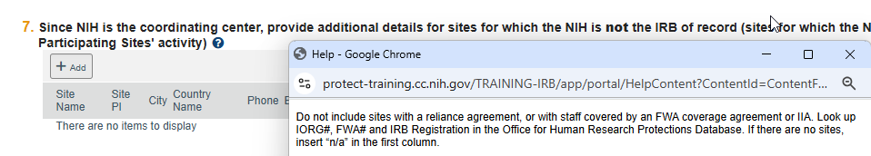

Change 4 – Revised RNI email notifications
The notifications about Reportable New Information submissions have been revised to display the studies/submissions they are related to.
This will apply to notifications sent when Clarifications are Requested by Staff or Committee, Outcome letters are sent, and Action is Required.
A new table will appear on these email notifications, as seen below:
