PROTECT Release Notes

Effective March 6, 2026

NEW/REVISED: Custom Report changes
1. All Exempt Studies (NIH) - Report was revised to only show Exempt Studies and some columns removed and others renamed.
2. All NHSR Studies (NIH) - Report was created to show Non-Human Subject studies.
3. All Studies - Report was revised and a few columns renamed.
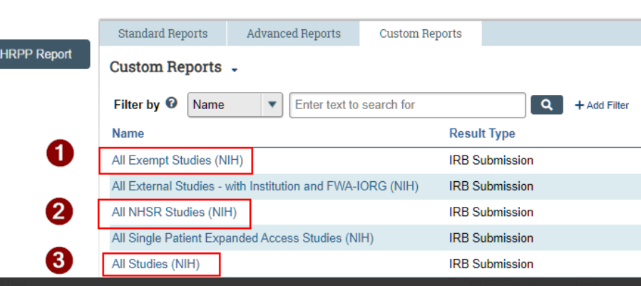
NEW: New NIH Site in Local Research Locations page
There is a new NIH research site in DC where some types of activities can take place. This site has been added to the IRB submission form > Local Research Locations page.
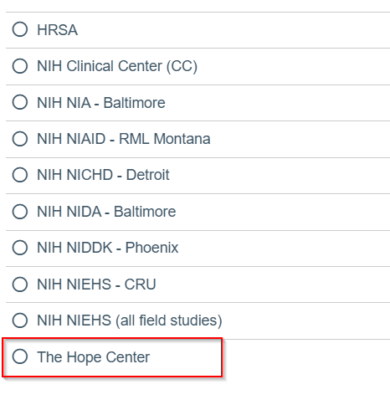

NEW: Two new required forms for CR/Closure have been posted (effective April)
In response to a recent New Requirement for CR supplement form and study closure memo requirement effective April 1, the corresponding forms have been stored in PROTECT under IRB Tab > Library > Templates.
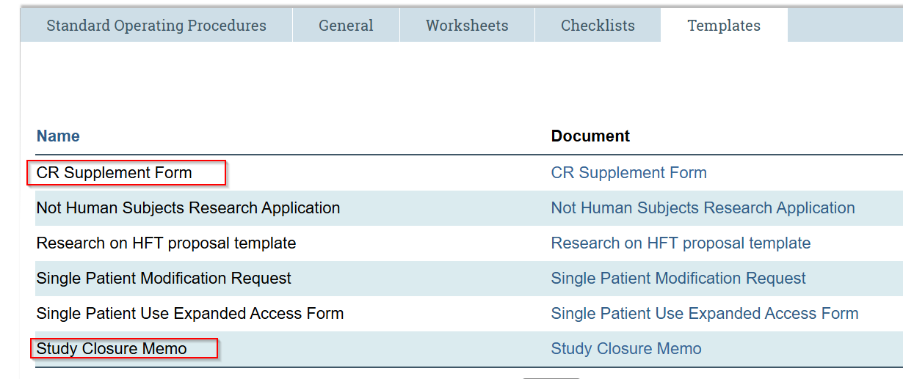
NEW: Two new NIH IRB Metric Reports on Our Website
On our website Intramural NIH IRB Metrics page there are two new reports that capture Non-NIH study approval volumes and approval timelines. The two existing reports that were on this page only reflected NIH submissions.
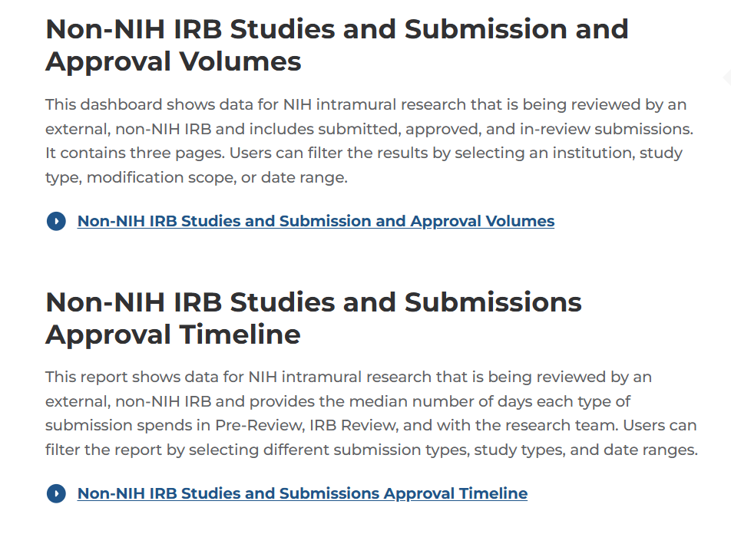
REVISED: Scientific Review Annual reminder notifications
As of February 19, 2026, Annual Scientific Review (SR) is now voluntary at the IC level. A statement has been added to the Annual SR reminder notifications explaining that if your IC does not require annual SR, then you may disregard the notification. We have received several inquiries about whether we can turn off these reminders altogether and we cannot as some ICs do require annual review. The solution to modify the notification language was agreed to by the Chief Scientific Officer. The overdue annual SR notification will no longer be sent out.
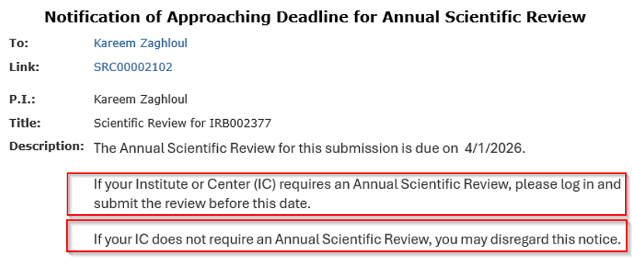

REVISED: Revised question text on the Local Site Documents page
We have removed the word “template” from the following two Qs since these sections are not for templates, but actual consents and recruitment materials.
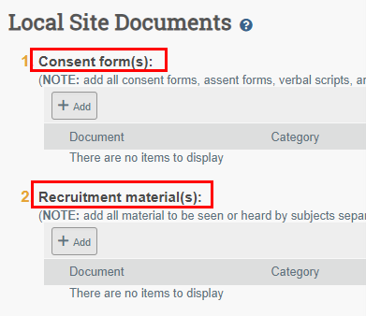
REVISED: Continuing Review submission form instructions
We updated the instructions in the CR form regarding the redacted consent(s). Instructions now include a note to explain to users why we want the printed name of the investigator to not be redacted.
We included this “note” because the investigator obtaining consent is not always the Principal Investigator and we have found that people are redacting the printed name of the investigator obtaining consent despite the instructions to leave it. Retaining the printed name helps us more clearly identify who obtained consent when signatures are difficult to read.
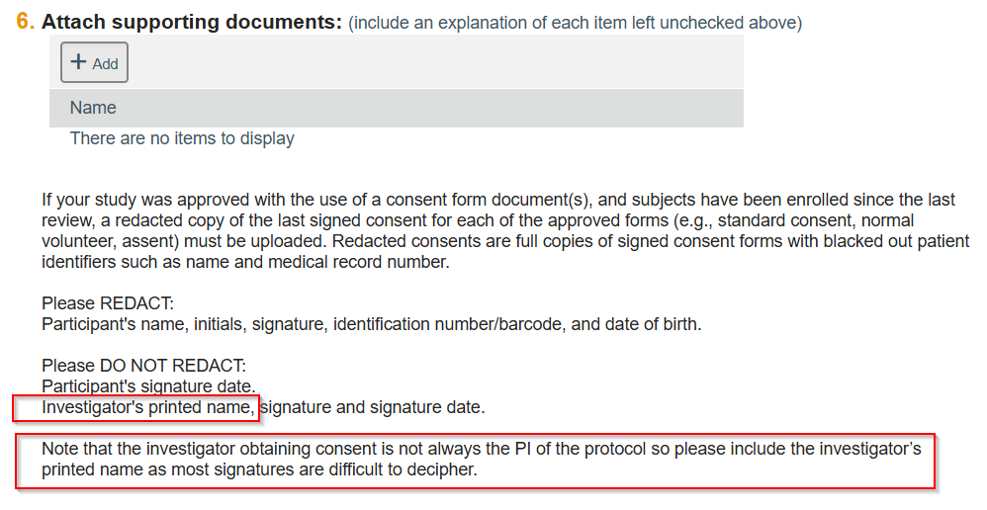

REVISED: PROTECT Document Upload instructions
We revised the upload instructions throughout the IRB and SRC submission forms to help avoid errors that have been occurring. When users retain a name/description in the Name (Q2) field when uploading a revised file, it was overwriting the file name and causing confusion about which document was the current document. Leaving this field blank ensures that the file name of the document updates correctly everywhere in PROTECT, such as Documents tab and outcome letters. We hope these changes result in less confusion and fewer errors.
Before uploading a brand new document (or updating an existing document), properly name your file on your computer using our IRB file naming guidance: Naming your documents. Naming guidance has also been linked on the forms for your convenience.
