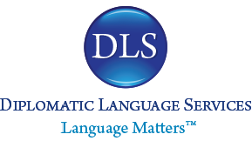

1901 N. Ft Myer Dr, 6th floor Tel: 703 243 4855
Arlington, VA 22209 Fax: 703 243 7003
www.dlsdc.com info@dlsdc.com

CERTIFICATE OF TRANSLATION

To Whom it May Concern:

I, Elizabeth (Liz) Redd, Translation and Interpretation Manager at Diplomatic Language Services, do hereby certify that the translation of the attached documents was executed by a professional translator competent to translate from English into Greek, and is to the best of my professional knowledge and belief, a true and faithful rendering of the original document in English.

In witness whereof, I have affixed my signature to the document:
File name:
NIH-19-370 [#41444] through NIH-19-396 [DT #41470]_NIH Short Form Consent_Greek_DLS_Final

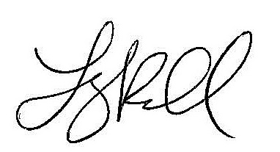
__________________________
Elizabeth (Liz) Redd, Translation and Interpretation Manager

7/26/2019
__________________________
Date

