How to Receive Email Updates About FDA Drug Label Changes

Step one
Click on this link to subscribe or manage subscriptions to FDA email updates. You will see the screen for the FDA Subscription Management Center. Enter and confirm your email address as instructed.
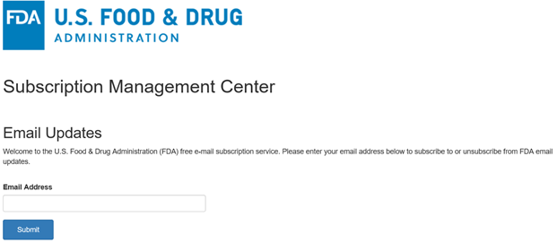

Step two
You will now see a list of all the possible FDA email update subscriptions. The subscription that sends out changes in approved drug labels is titled “CDER Drug Safety Labeling Changes”. You may choose any additional FDA updates that you may be interested in receiving. You can always change this later.
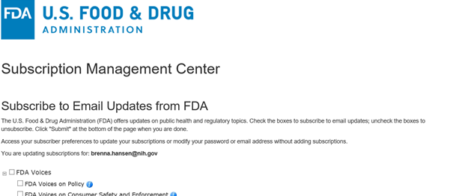
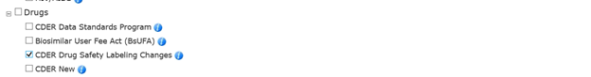

Step three
Save your changes and then you are done.
